**SETTING UP REMOTE/DEDICATED MYSQL SERVER FOR APPLICATION/WEB SERVER**

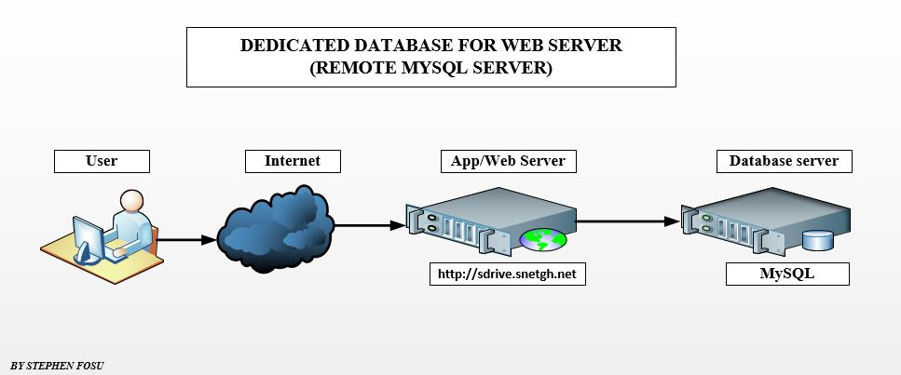

**INTRODUCTION**

As your application or website grows, you may come to a point where you've outgrown your current server setup. With servers hosting large websites, resource usage is a big issue and in most cases MySQL is consuming the majority of the resources. To avoid this, setting up a separate standalone MySQL server and loading the websites from there is a very good option. MySQL server will be installed in a remote machine/server and websites loading from the local web server are tied to the databases in the remote MySQL server.

**INSTALLING MYSQL SERVER ON THE UBUNTU**

Step 1) First we need to install MySQL in a remote server.

Using the console command line. In your terminal enter

root@snet[~]# sudo apt-get install mysql-server

**Or**

root@snet[~]# sudo apt install -y mysql-server mysql-client

**CONFIGURE MYSQL SERVER TO LISTEN TO ANY IP**

Step 2) Make the MySQL server listen to any IP or your private or public IP, so that the web server will be able to reach the MySQL server.

Use the following command:

root@snet[~]# nano /etc/mysql/mysql.conf.d/mysqld.cnf

Search the configuration file for ***bind-address*** and change

bind-address = 127.0.0.1 to bind-address = 0.0.0.0

root@snet[~]# sudo systemctl restart mysql

**CREATING OF MYSQL USER, DATABASE AND GRANTING PRIVILEGES**

Step 3) Create the MySQL user and database and grant privileges to access this from the web server.

**USING PHPMYADMIN OR ANY GRAPHICAL USER INTERFACE (WORKBENCH, ADMINER)**

Login into your phpmyadmin and click on “user accounts”

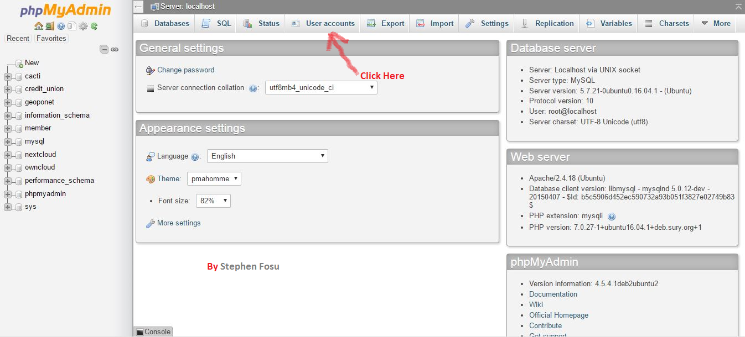

Click on the “Add user account” to add new user

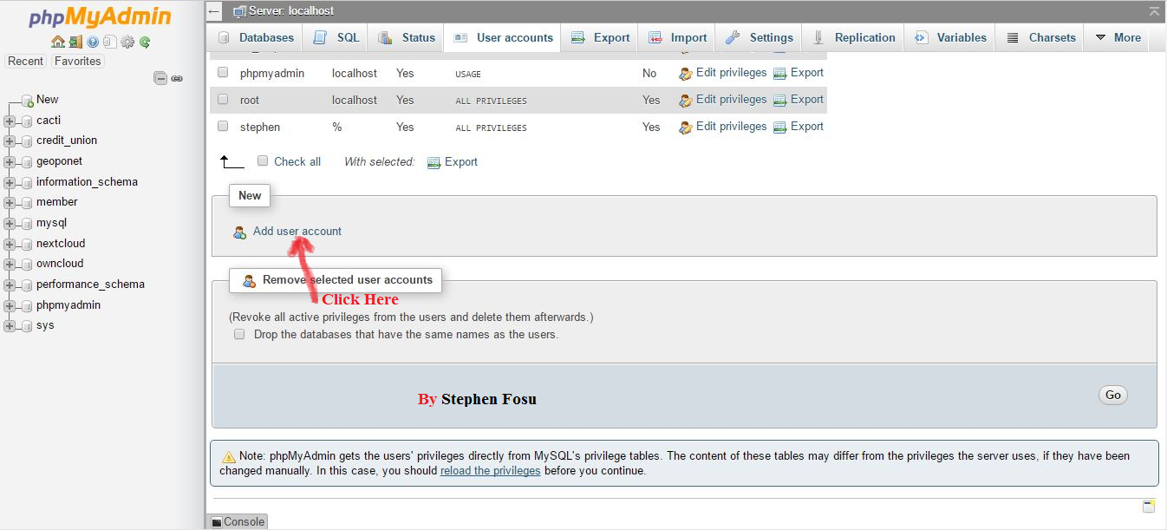

Add username, host name (leave it on default (any host)) and password

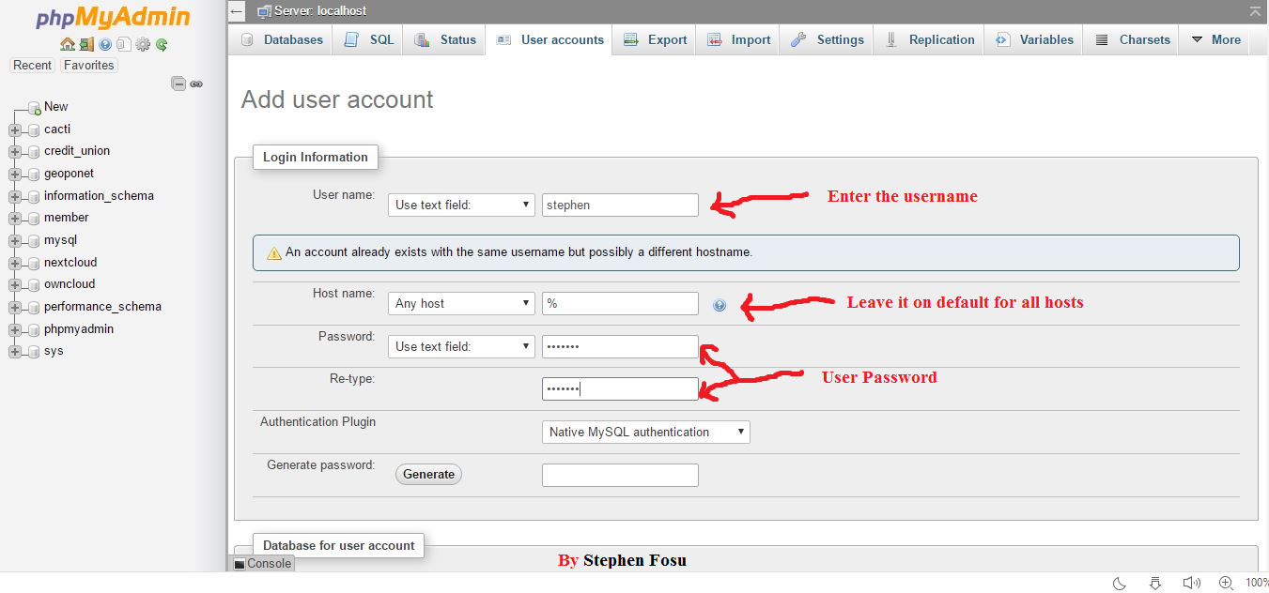

Grant the user all privileges by clicking “Database for user account and Global privileges”. Then click for “Go” to finish.

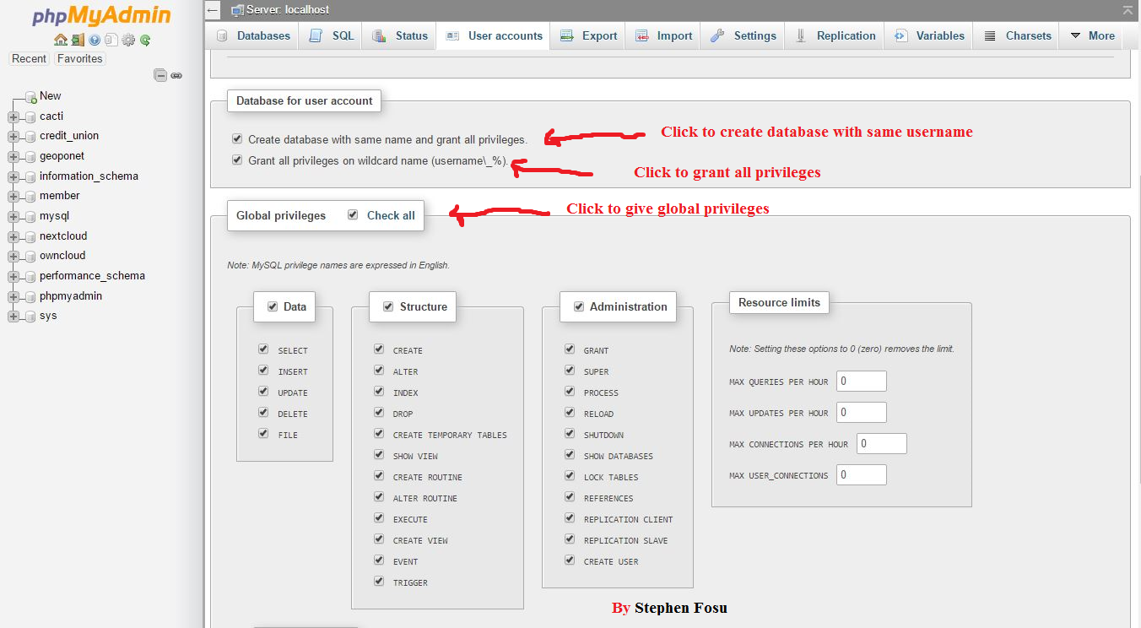

**USING THE CL (CONSOLE COMMAND LINE)**

root@snet[~]# mysql -u root -p

Enter MySQL password

Create a MySQL database for snetgh application/website present in the web server.

root@snet[~]# CREATE DATABASE snetgh;

Create MySQL user who can access this database from the web server and assign a password for it.

root@snet[~]# CREATE USER 'sdrive'@'%' IDENTIFIED BY 'password';

**OR**

root@snet[~]# CREATE USER 'sdrive'@'172.168.1.90' IDENTIFIED BY 'password';

Grant all privileges to the MySQL user to access this database.

root@snet[~]# GRANT ALL PRIVILEGES ON snetgh.* TO 'sdrive'@'%’;

**OR**

root@snet[~]# GRANT ALL PRIVILEGES ON snetgh.* TO 'sdrive'@'172.168.1.90’;

root@snet[~]# FLUSH PRIVILEGES;

root@snet[~]# exit

***Note:*** % means any host or 172.168.1.90 is the webserver’s IP. Then restart MySQL Server

root@snet[~]# sudo systemctl restart mysql

**VERIFY DATABASE ACCESS FROM THE WEBSERVER**

Step 4) On the web server, enter the following command to verify the connection works:

root@snet[~]# mysql -u sdrive -h 172.168.1.80 -p

Enter the MySQL user password

If the MySQL monitor displays as follows, the database is ready

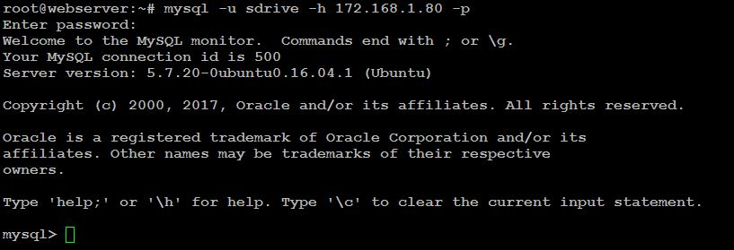

The 172.168.1.80 is the MySQL server’s IP

***BY STEPHEN FOSU***